Name:Shahnwaz Khan

Roll: Ac-1272

Department: B.Sc. Cs(Hons)

Batch: 2020-23

Index.html

<!DOCTYPE html>

<html>

    <head>

        <title>Lab 9</title>

    </head>

    <body>

        <!-- Gallery -->

<div class="row">

    <div class="col-lg-4 col-md-4 col-sm-12 mb-4 mb-lg-0 ">

      <img

        src="./C6.jpg"

        class="w-100 shadow-1-strong rounded mb-4"

        alt="Boat on Calm Water"

      />

      <img

        src="./C1.jpg"

        class="w-100 shadow-1-strong rounded mb-4"

        alt="Wintry Mountain Landscape"

      />

    </div>

    <div class="col-lg-4 mb-4 mb-lg-0">

      <img

        src="./C2.jpg"

        class="w-100 shadow-1-strong rounded mb-4"

        alt="Mountains in the Clouds"

      />

      <img

        src="./C3.jpg"

        class="w-100 shadow-1-strong rounded mb-4"

        alt="Boat on Calm Water"

      />

    </div>

    <div class="col-lg-4 mb-4 mb-lg-0">

      <img

        src="./C4.jpg"

        class="w-100 shadow-1-strong rounded mb-4"

        alt="Waves at Sea"

      />

      <img

        src="./C5.jpg"

        class="w-100 shadow-1-strong rounded mb-4"

        alt="Yosemite National Park"

      />

    </div>

  </div>

  <!-- Gallery -->

    </body>

</html>

Ouput1

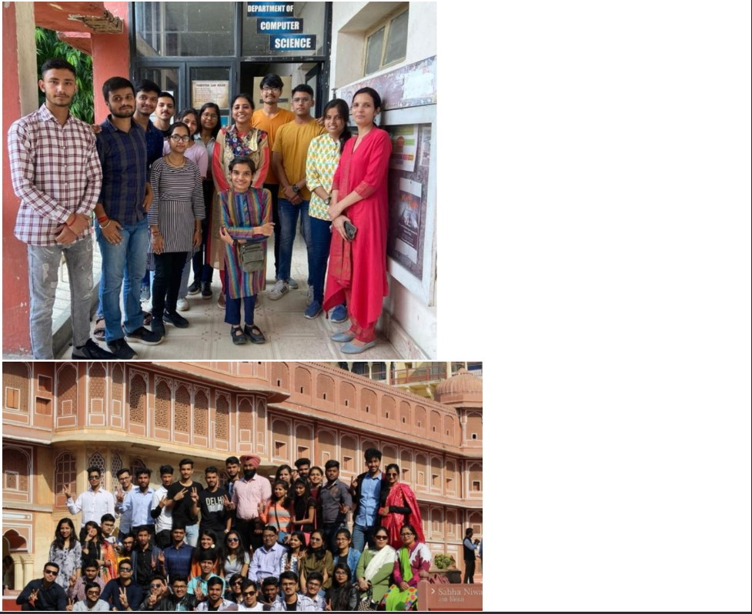

Output2:

